Morphological Operations Using Dilation
Experiment No: 30
Aim
To perform the morphological dilation operation on an image using OpenCV in Python.
Tools Required
- Python 3.x
- OpenCV (cv2)
- NumPy
- VS Code / PyCharm / Jupyter Notebook
- Input image (image.jpg)
Theory
Dilation is a morphological image processing operation that expands or thickens the foreground objects in an image. It is useful for filling small gaps, connecting nearby objects, and increasing the size of foreground regions.
Dilation is performed using a structuring element (kernel).
Procedure
- Install OpenCV and NumPy:
Bash
pip install opencv-python numpy
- Read the input image using OpenCV.
- Convert the image to grayscale.
- Create a structuring element using NumPy.
- Apply the dilation operation using cv2.dilate().
- Display the original and dilated images.
- Save the resulting image.
Code
import cv2
import numpy as np

# Read the image
image = cv2.imread("image.jpg")

# Check if image is loaded
if image is None:
print("Error: Image not found!")
exit()

# Convert image to grayscale
gray = cv2.cvtColor(image, cv2.COLOR_BGR2GRAY)

# Create a structuring element
kernel = np.ones((5, 5), np.uint8)

# Perform dilation
dilated = cv2.dilate(gray, kernel, iterations=1)

# Display original image
cv2.imshow("Original Image", gray)

# Display dilated image
cv2.imshow("Dilated Image", dilated)

# Save the dilated image
cv2.imwrite("dilated_image.jpg", dilated)

cv2.waitKey(0)
cv2.destroyAllWindows()
Output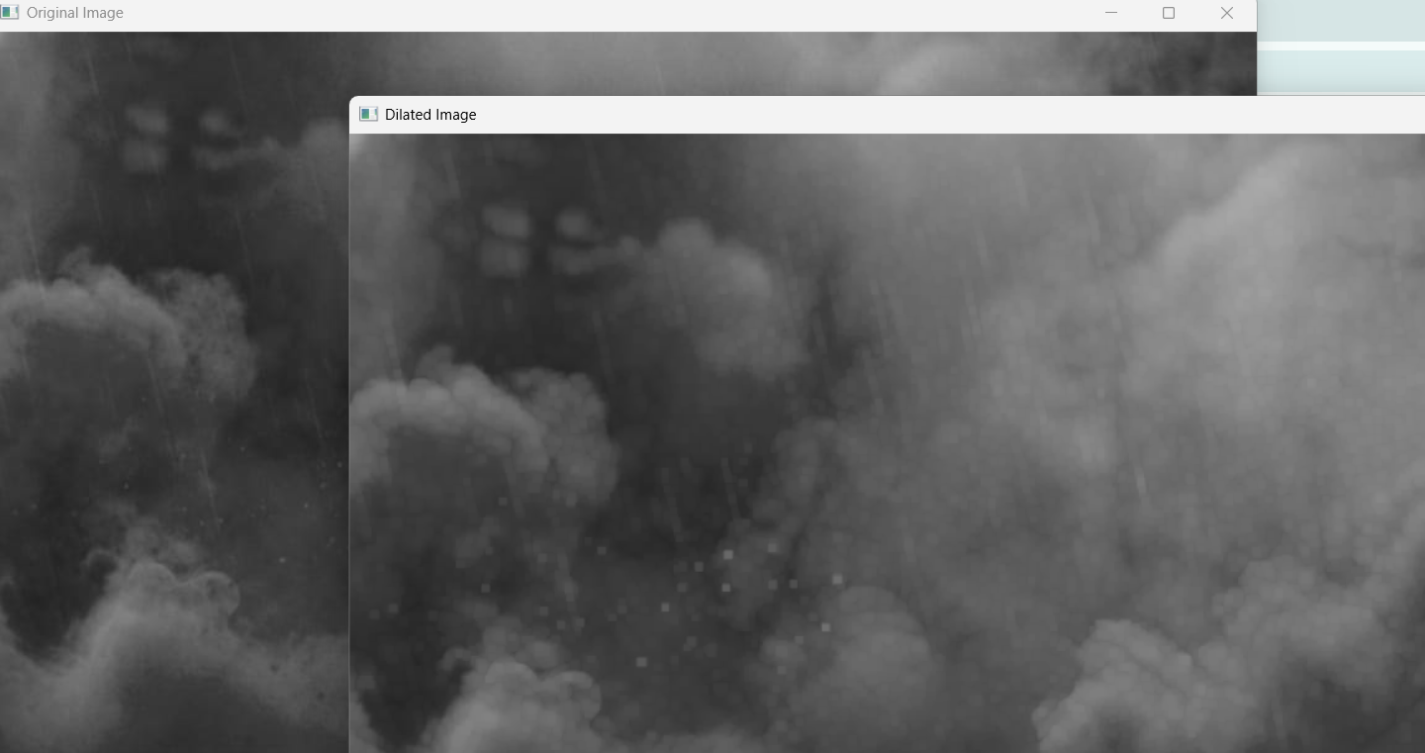
Result
The morphological dilation operation was successfully performed using OpenCV. The cv2.dilate() function with a 5 × 5 structuring element expanded the foreground regions and produced the dilated image successfully.

